Honeywell Genesis 7680g
Tastatur-Modus
05.06.2024
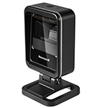
Reset the Factory Defaults: Activate Defaults
Cellular Telephone Reading Mode: On
Keyboard Country: Germany
Keyboard Modifiers: Windows Mode Control + X
Dead Key Thru Alt+Numpad Sequence: Windows System Code Page
Prefix: STX
Suffix: ETX
Presentation Aimer Mode: Interlaced


DEFALT;KBDCTY4;KBDCAS2;KBDALT4;HSTACH18;HSTDCH20;DECCEL1;PREBK29902;SUFBK29903;PDCAIM2.

